Pricing computing balance +PLU
User Manual

EE40010

Content
1 Notice 2
2 Specification 2
3 Main parameter 3
4 Display 3
5 Indicator 4
6 Charging 4
7 Operation 4
8 Counting function 6
9 Zero 6
10 TARE 7
11 Totalizer 7
12 PLU function 8
13 User simple calibration 9
14 Hi-Lo function 9
15 Parameter setting 10
16 Error message 13

- Notice
  - Please charge before first use.
When low power sign shows, please use the original adapter to charge. Charge light is red, it means scale is in charging mode. When charge light turn to green, it means charging finished. The charging time is about 8-10 hours.
  - Put and balance the electrical scale on the stable and flat table with four adjustable feet. Please notice the air bubble should be kept in the center of circle.
  - Please avoid the water.
  - When the value of the scale is not zero, press “Zero”, zero will come.
  - If mobile or wireless machines are in use nearby when turning on the scale, the display will flash once, and then become normal. If it doesn't work, please turn on again.
  - The original adaptor should be used when charging.
  - After a long-time use (more than one year), the rechargeable battery can't keep using for long after more than 12-hour charging, which means new one should be replaced. If you have no idea how to replace, please ask a nearby agency to give you a helping hand.
  - Please turn off the scale when it won't be used for a long time.
  - Avoid putting the weight on the scale when turning it on.

- Specification
  - Big size LCD/LED display, easy to read.
  - More backlight setting to fit the requirements.(LCD)
  - More brightness setting to fit the requirements.(LED)
  - Solid frame design to insure the stable weighing.
  - With data memory, can store many weighting date.
  - Fast reading, stable, accurate, easy using.
  - Low power alarm, charging light show.

- Main parameter
  - Division: 1/6000
  - Power:50mA(LCD)/150mA(LED)
  - Display: LCD/LED display
  - Load cell range: 3mV/V
  - Adaptor:DC6V/4.5AH(when battery voltage less than5.6V,it will show the sign of low power)
  - Temperature&Humidity:0-40℃, lessthan90%RH
  - Storage: -25~55℃

- Display
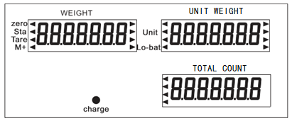
  - Weight-----The weight of goods.
  - Unit weight------The unit weight of goods.
  - Total CountThe total count of goods.
  - [◄]-----To choose, indication of Units.
  - Zero----Weight value is 0.
  - Tare-----Used as tare key in pricing mode
  - Stable----Weight value is stable.
  - Lo-bat---When battery power lower than 5.6V, it will show.

- Indicator
  - The connection
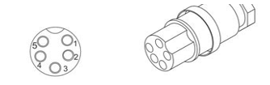
PIN | definition | note
1 | E+
2 | E-
3 | S+
4 | S-
5 | Ground | Connect to the shield wire
  - How to fix
Put the cable through the pillar, then insert the pillar into base, fasten the fixed screw. After put the cable through the holder. Insert the holder into the bracket of the indicator. Fix the load cell connector. Adjust the holder for right position, and then fasten the plastic screw on the display.

- Charging
When charging, the light is red. It will turn green when charging finished (the charging time should be 8-10h).
Attention: do not use up the battery, otherwise the battery will be broken. If user do not use it for a long time, should recharge in 40 days.
After charge, please take off the power supply, do not always connect to power supply.

- Operation
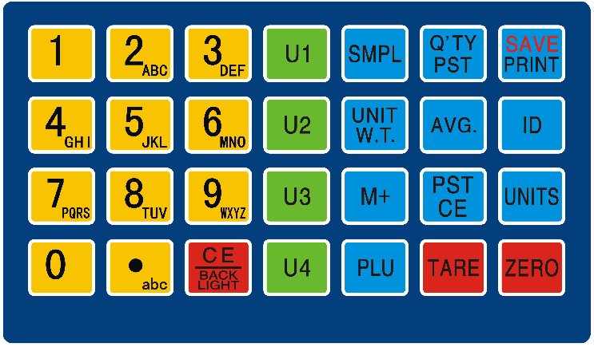
  - [0-9] The digital key, input the unit weight. In letter input mode can input letters.
  - [.abc ] The decimal point key. When input item SKU number, this key can switch input number or letter.
  - [Unit] Select the pricing computing units.
  - [Zero] Let the weight display's value back to zero.
  - [Tare] Put on the tare weight, the press this key to deduct the tare weight.
  - [CE] When input wrong unit weight, press this key can clean the wrong numbers. If the interval time of input numbers more than 5s, the scale will clean the number which input before 5s, and read the number which input after 5s as new input one.
  - [Q’TY PST] Get sample’s unit weight by enter weights quantity.
  - [UNIT W.T.] Enter the unit weight value.
  - [M+] Add up unit weight and total quantity. When weight is 0, this key use to reshow, to show the accumulated price.
  - [PST CE] Clean the accumulated quantity.
  - [Q’TY PST] Set the HI-LO alarm.
  - [AVG.]Open/Off auto-average function. When open this function, an arrow will show on the display and point to the AVG. sign.
  - [ID] Use to input the SKU ID.

  - [PLU] use to get the stored PLU value. E.g. input number 12, then press [PLU], the No.12 stored PLU values will show. (Include unit weight, SKU id…)
Also can press [PLU] key for 3s to enter the PLU setting.
  - [U1]- [U4] Get the stored PLU value directly.
  - [Print] In weighing mode and recheck mode, press this key can print out the content.
- Counting function
  - Unit weight of weights is unknown
Please put the sample weights on the pan, enter the sample’s quantity by use number key, then press [SMPL] key. After the weight value is stable, the total count window will show the quantity of the total weights, and the scale will enter into weighing mode.
  - Unit weight of weights is known
Input the known weight of weights, press [UNIT W.T.] key, and the total count window will show the quantity, and the scale will enter into counting mode.
*** The quantity of sample is bigger, the counting accuracy is higher.
*** When unit weight window and total count window all shows zero, user can press [SMPL] or [Q’TY PST], to reshow the last unit weight.
*** After get unit weight by [PLU] key, if the error between the unit weight and sample weight of the next weights is more than +-10%, the scale will recount and get a new unit weight, to increase the counting accuracy. User can open or close the auto-average function in F2 AVG or press [AVG.] key.
*** If unit weight and quantity are known, after user press [UNIT W.T.], the scale will recount according the quantity in total counting window.

- Zero
When here’s no weights on the pan, user press [Zero], weighing value will back to zero. If the scale damaged or weighs heavy than allowed zero range, [Zero] key is invalid. If the pan is empty and display still have residual value, please use zero function. The range of zero= Max. Cap.*4%.

- TARE
  - Tare weight is unknown
Put the container on the pan, press [Tare] key, after the scale is stable, net weight will show in the weight window and tare sign will appear.
  - Tare weight is known (Pre-tare)
When the pan is empty, press [Tare] key, the display will show “PRE-SET TARE”. Input the weight of the container, press [Tare] key, Pre-tare complete. User can set follow function ON or OFF in F5 PTE:
In weighing mode, when tare weight is known, input tare weight, then press [Tare] key to Pre-tare.
Specific operation as follows:
Put the container and weights on the pan, input the container’s weight and press [Tare] key, the weight window will show the net weight of the weights. Take away the container and weights, the weight windows will show a negative value. At this time, press [Tare] key to remove the tare weight value. Now, the weight window back to zero.

- Totalizer
  - This Totalizer function can add up 99pcs weighing data. If the accumulative number is out of 99, the new data will cover old data according to the order.
  - When total count window shows value, press [M+] key can enter into totalizer mode. At this time, the total count window shows “Add XX”, XX means the accumulative number. After 3s, the scale will back to counting mode automatically.
  - Show the accumulated data
When the weight window shows zero, press [M+] key to show the accumulative data. First, the scale will show total accumulative data, press [M+] again, the scale will show every weighing data one by one.
When the scale shows one of the weighting date, press [PST CE], all accumulated data will be deleted.
Let the scale back to weighing mode, press [CE] key.
In 8.3, when the scale shows accumulated total price, press [PST CE], all accumulated data will be deleted. When scale shows one of the accumulated data, press [PST CE], just this accumulated value will be deleted.
In weighing mode, press [ PST CE], all accumulated will be deleted.

- PLU function
  - In pricing computing mode, use number keypad to input PLU serial number, then press [PLU],can get the weights name and unit weight of the corresponding weights. The display will show the item name once and back to pricing computing mode.
  - Edit the PLU data
In pricing computing mode, press and hold [PLU] key for 3s to enter PLU date edit mode.
    - The weight window shows “set”, user input the PLU serial number, then press [PLU] (or press “Ux” key directly), the weight window will show the input PLU serial number. Now, scale enter into unit weight edit mode.
    - If this PLU serial number already stored, the weight window will show the stored unit weight. If it is a new one, the weight window will show the unit weight which get in pricing computing mode. In this two way, user can edit the unit weight by use keypad.
Press [PLU] again to store the unit weight and enter SKU ID edit. User can use number and letter keypad to input. SKU ID can include letter, please check the step 12.4 to get how to input. After input, press [PLU] to store. Then back to the step 12.3.1 to edit the next SKU ID. If finish, press [CE] to exit.
Some models do not have SKU ID edit function. After store the unit weight, the scale will back to step 12.3.1.
  - Input letter
Press [.ABC] once, there will have an arrow sign appear on the display point to “ABC”, or show an “ABC” sign on the display. This means enter to letter input mode.
Now, user can input letter by use number keypad. E.g. press [1abc] once, the display will show “A” and blink, press once again, the display will show “B”, and so on. After the letter stops blink, it means this letter has been inputted. Back to number input mode, press [.ABC], the letter input sign will disappear also.

** This PLU function can use our software to edit by PC. Use software can edit goods name and expiration date. Want to know more, please contact the local agent.

- User simple calibration
  - At this time, the pan must be empty.
  - Power off the scale, press [Q’TY PST] and hold, power on the scale.
  - Wait the unit weight window shows zero, use number key to input the weights value(Default unit is kg) .Then put on the weights on the pan, after the scale become stable, calibration runs automatically. If the scale doesn’t run calibration automatically, please press [Q’TY PST] to run calibration after the scale is stable.
  - If user do not need calibration, please restart the scale.

- Hi-Lo function
In common counting mode, press [Q’TY PST] key to enter Hi-Lo function, setting details as follows:
Display | function | Manual
LIMOF | Set the alarm depends on weigh t or count. | Press [M+] to set, press [Q’TY PST] key to enter the next parameter setting.
CHLMod  -H L- | Set the mode of Hi-Lo alarm. H means high level, L means low level. The line on the left side of H means alarm when weight is bigger than high level. The line between H and L means alarm when the weight is between high and low level. The line on the right side of L means alarm when weight is less than low level. | Press [M+] to set, press [Q’TY PST] key to enter the next parameter setting.
10LIM-Hi | This is high level value. (When alarm by weight, the unit is kg). | Use number key to input the value. Press [Q’TY PST] key to enter the next parameter setting.
LIM-Lo | This is low level value. (When alarm by weight, the unit is kg). | Use number key to input the value. Press [Q’TY PST] key to counting mode.

- Parameter setting
  - In weighing mode, press and hold [PLU] key, then press [CE] key, the scale will enter into user parameter setting mode.
  - In parameter setting, press [Print] key to enter the major term, press [PLU] to enter to the detail parameter setting, press [M+] to modify the value of parameter.

  - Parameter settings
Major term  (Press [Print]) | Parameter  (Press [PLU] to go next step, [M+] key to modify the setting) | Function details
P1 TRA  (Communication Settings) | T1 FC | Communication mode:  1 continuous sending mode  2 stable sending mode,  3 answer sending mode  4 manual sending mode  5 stable print mode  6 manual print mode  5 and 6 work for printer connected.
 | T2 Add | Communication Address, effective in multi-machine communication.
 | T3 Bps | Communication baud rate settings
 | T4 Fmt | Communication mode. The parameter can be set to: n81 check bit/o71 data bit /e71 stop bit.
 | T5 PFM | Communication protocol settings. The default setting is 0. When scale connects to the printer, this setting use to set print format.
 | T6 Chk | Turn on/off XOR check.
 | T7 PF2 | Inside printer’s print format.(Option)
P2 FUN  (Function settings) | F1 BL | LCD version use to set backlight, can set to ”ON”, ”Auto”, ”OFF”.
 | F1 LtN | LED version use to set brightness, can set to 0-2. The number is bigger, the digits are brighter.
 | F1C SL | Sleep time setting. LCD version is the waiting time of auto mode.
 | F2 ARG | Open or close unit weight auto correction function.
 | F3 CST | To set if Zero, tare, M+…, functions need wait stable to effect. ON means need wait, OFF means do not need.
 | F4 MAE | To set if next M+ can run after last M+ after zero. ON means M+ without zero. OFF means need.
 | F5 PTE | To set if pre-tare can run when weights on pan. ON means can, OFF cannot.
 | F6 UNT | Unit in use.
 | F7 FIL | The reaction seep of scale. The value is smaller, the speed is faster, but more unstable. The value is bigger, the speed is slower, but more stable.
 | F8 ZPE | To set if the scale can alarm when weight is 0.
 | F9 FAL | ON means full alarm mode. OFF means simple alarm mode.
 | F10 BC | To set if the Hi-Lo relay runs after stable.

- Error message
Message | Problem | Solve way
ADO--- | Over A/D resolution range | Remove the weights of the pan or send back to the agent.
ADL--- | Over A/D resolution range | Remove the weights of the pan or send back to the agent.
OVR--- | Over load (max: capacity +9e) | Check the weight of the weights, cannot exceed Max Cap.+9e
Battery symbol flash | Low power alarm | Charge battery
Lo-Bat | Low power alarm | Charge battery

